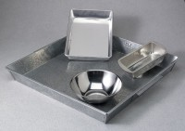 | Mixing Pan - Rectangular Stainless - 11" x 9" x 3"  Code: 88-7130  Product Group: Mixing Pans and Bowls  Stainless steel; 11” x 9” x 3” (279 x 229 x 76 mm).

