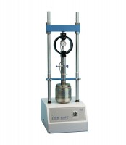 | CBR-Test 50 Machine 50 kN Capacity BS and ASTM Supplied with Stabilising Bar.  Code: 24-9150/02  Product Group: Load frames, CBR-Test 50 Machine

Standards
AASHTO T99, AASHTO T134, AASHTO T135, AASHTO T136, AASHTO T180

Further Information
110-120vAC, 50/60 Hz, 1ø.
Proving Ring, Penetration Piston assembly and penetration dial indicator not included, order separately

Specification
Capacity | 11 ,200 lbf. (50 kN).
Horizontal Clearance | 10” (255 mm).
Vertical Clearance | 31 .5” (800 mm) maximum.
Platen | 5.24 ” (133 mm) diam.
Platen Travel | 4.13 ” (105 mm).
Dimensions | 15 .75” w. x 21 .65” d. x 48” h. (400 x 55 0 x 1,22 0 mm).
Weight | Net 269 lbs. (122 kg).

Spares/Consumables
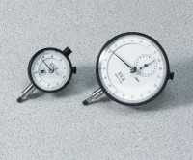 | Dial Indicator - 1.0" Range  Code: 88-4100

