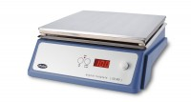 | Digital Hotplate  Code: 78-3104/01  Product Group: Digital Hotplate

Further Information
**Not available for sale in the USA**

Specification
Dimensions | 520 x 360 x 130 mm
Construction | Robust metal with anodised aluminium plate heated surface
Maximum temperature | 300 x 1ºC
Rated power | 1500 W

