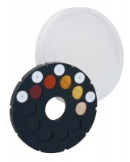 | Colour Standard to ASTM C40  Code: 42-3040  Product Group: Organic Impurities Test, Color Standard Chart, Organic Impurities in Fine Aggregate  With five organic colour transparencies mounted in a holder.

Standards
ASTM C40, AASHTO T21

Specification
Color Standards | Five, on non-fading glass.
Dimensions | 3â w. x 2-7/8â d. x 4â h. (76 x 73 x 102 mm).
Weight | Net 4 oz. (113 g).

Spares/Consumables
 | Sodium Hydroxide Solution  Code: 42-3050

