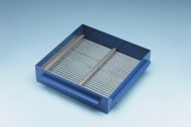 | Grid Sieve 6.3mm Slot Width for EN Aggregate Flakiness Test.  Code: 42-0308  Product Group: Grid Sieves  6.3mm

Standards
EN 933-3

Further Information
**NOT AVAILABLE FOR SALE IN THE USA**
Passing Size - 12.5 mm Retained Size - 10mm

