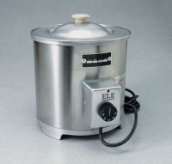 | Capping Compound Warming Pots 110vAC  Code: 34-6125/02  Product Group: Capping Compound Warming Pots  4 Qt. (3.7 liter) capacity.

Further Information
110vAC, 50/60
Hz, 1ø. 1,250 Watts.110vAC, 50/60
Hz, 1ø. 1,250 Watts.110vAC, 50/60
Hz, 1ø. 1,250 Watts.110vAC, 50/60
Hz, 1ø. 1,250 Watts.110vAC, 50/60
Hz, 1ø. 1,250 Watts.110vAC, 50/60
Hz, 1ø. 1,250 Watts.110vAC, 50/60
Hz, 1ø. 1,250 Watts.

Specification
Capacity | 4 qt. (3.7 liters).
Temperature Range | 150Â°F to 45 0Â°F (65Â°C to 25 0Â°C).
Control | Adjustable, automatic thermostat with pilot  light.
Construction | Round aluminum pot with steel jacket; with  cover.
Inside Dimensions | 8â diam. x 5-1/2â d. (203 x 14 0 mm).
Outside Dimensions | 9â diam. x 10â h. (22 9 x 254 mm).
Weights | Shpg. 13 lbs. (5.9 kg).

