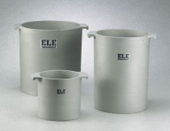 | Unit Weight Measure 1/10 cu. Ft. Capacity  Code: 34-2850  Product Group: Unit Weight Measures, Unit Weight Measures  1/10 cu. Ft. Capacity

Standards
ASTM C29

Specification
Construction | Cast aluminum; machined inside; with handles.
Top Rim | Machined smooth; parallel with bottom.
Inner Dimensions | 6â (152 mm) i.d. x 6.1â (154 .9  mm) inside h.
Weights | Net 6-1/2 lbs. (2.9 kg).

