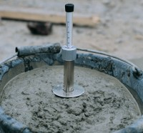 | K-slump Tester  Code: 34-0580  Product Group: K-Slump Tester, K-Slump Tester  Developed to determine the workability of fresh concrete and the degree of concrete compaction placed in formwork. The apparatus can be used for in-place measurements of concrete in test moulds and forms and may be correlated to the standard slump test. It is simple, economical to use and reduces testing time. No special calibration is required.

Specification
Construction | Nickel Plated Steel. Calibrated 3/4" (19 mm) diam. Hollow tube; pointed insertion end; round disc controls depth of penetration.
Openings | Two groups through which concrete enters.
Test time | 60 seconds
Weight | Net 1 lb (445 g)

