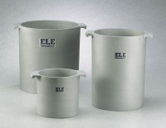 | Unit Weight Measure 1/2 cu. Ft. Capacity  Code: 34-2854  Product Group: Unit Weight Measures, Unit Weight Measures  1/2 cu. Ft. Capacity

Standards
ASTM C29

Specification
Construction | Cast aluminum; machined inside; with handles.
Top Rim | Machined smooth; parallel with bottom.
Inner Dimensions | 10â (254 mm) i.d. x 11 â  (279 mm) inside h.
Weights | Net 19 lbs. (8.6 kg).

