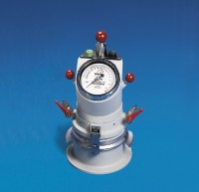 | Air Entrainment Meter  Code: 38-7087  Product Group: Air Content of Mortar, Masonry Cement and Lime by the Pressure Method  0.75 litre capacity, complete with integral pump.

Standards
EN 413-2, BS 459-2

Further Information
**NOT AVAILABLE FOR SALE IN THE USA**

