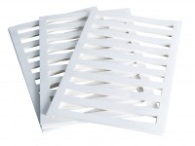 | Filter Paper Drain 50mm Diameter. Pack of 50  Code: 25-5580  Product Group: Accessories for CU/CU effective stress, Filter Paper Drains  Filter paper drain 50 mm diameter (Pack Of 50).

