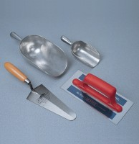 | Aluminium Scoop Small  Code: 81-0200  Product Group: Scoops and Shovels  82 x 127 x 50 mm, cast aluminium with handle

Further Information
**NOT AVAILABLE FOR SALE IN THE USA**

