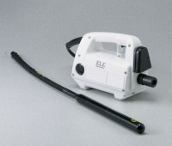 | Laboratory Vibrator  Code: 34-6430/02  Product Group: Laboratory Vibrator

Further Information
110vAC or DC, 50/60 Hz, 1ø.

Specification
Tip | 1-3/8â diam. x 14 â l. (35 x 35 6 mm).
Shaft | 24 â l. (610 mm).
Speed | 10,000 rpm.
Motor | Electric.
Weight | Net 14 lbs. (6.3 kg).

