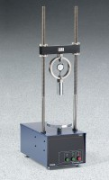 | Basic 4" Marshall Stability Test Set with Manual Compaction  Code: 5002/02  Product Group: Basic 4" Marshall Stability Test Set with Manual Compaction  SET INCLUDES:  1 - Marshall Stability Tester (45-6832/02).  1 - 4" Breaking Head (45-6855).  1 - Flow Indicator (45-6892).  1 - Stability Compaction Hammer (45-6460).  1 - Compaction Mold Holder (45-6414).  1 - Compaction Pedestal (45-6416).  2 - 4" Compaction Molds (45-6310).  1 - Asphalt Sample Ejector (45-6480).  1 - 4" Filter Paper Discs, pkg. of 100 (45-6462).  1 - Water Bath (45-6475/02).

Standards
ASTM D6926, ASTM D6927, AASHTO T245

Further Information
110vAC, 60 Hz, 1ø.

