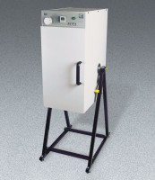 | ELE Rotasift Laboratory Sifter - 220V  Code: 80-0417/01  Product Group: ELE Rotasift Laboratory Sifters  220vAC, 50 Hz, 1ø.

