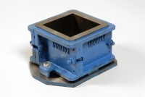 | 100mm Cube Mould 4-Part Clamp Type. Cast Iron Construction. BS EN Compliant.  Code: 34-4520  Product Group: Cube Moulds, Cube Moulds  4-part with clamp attached base plate.

Specification
Construction | Bolted sides and clamped base plate
Finish | Painted
Weight | 20 lb (9.1 kg)

