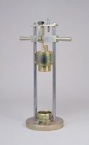 | Aggregate Impact Value Apparatus Complete with 16mm Dia X 600mm Long Rod  Code: 42-4000  Product Group: Aggregate Impact Value (AIV)  Heavy duty construction, heavily plated assembly ensures corrosion resistance.

Standards
BS 812-112

Further Information
**NOT AVAILABLE FOR SALE IN THE USA**

