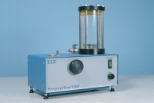 | Pressure Test 3500 Oil/Water Constant Pressure System with Digital Pressure Gauge.  Code: 70-5130/01  Product Group: Permeability of Rock  • Sealed oil reservoir  • Continuous constant pressure control  The ELE oil/water constant pressure system provides continuous variable pressure. The machine features a clear hydraulic/water interface reservoir, and digital pressure gauge range 0-3500 kPa.

Further Information
Complete with 2 litres of oil and digital pressure gauge. For 220 – 240 V AC, 50 – 60 Hz, 1 ph.

Specification
Dimensions (l x w x h) | 240 x 400 x 500 mm
Maximum pressure | 3500 kPa
Usable oil capacity | 1 litre
Weight | 12 kg

Spares/Consumables
 | Spare Jacket Nx Size.  Code: 70-1712

