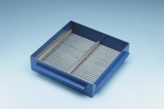 | Grid Sieve 3.15mm Slot Width for EN Aggregate Flakiness Test.  Code: 42-0302  Product Group: Grid Sieves  3.15mm

Standards
EN 933-3

Further Information
**NOT AVAILABLE FOR SALE IN THE USA**
Passing Size - 6.3 mm Retained Size - 5 mm

