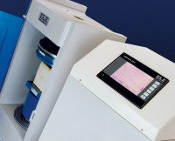 | Console Assy ADR-Auto V2.0  Code: 37-4880/01  Product Group: Compression Machine Upgrades  For upgrading ELE concrete compression machines manufactured after 1983. For 220 - 240 V, 50 Hz, 1 ph.

Further Information
**Not available for sale in the USA**
220-240V 50Hz

