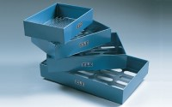 | Set of Flakiness Sieves Comprising 1 Ea 4.9mm 7.2mm 10.2mm 14.4mm 19.7mm 26.3mm and 33.9mm  Code: 42-0600  Product Group: Flakiness Sieves and Gauges  Comprising of 1 each, 4.9 mm, 7.2 mm, 10.2 mm, 14.4 mm,19.7 mm, 26.3 mm and 33.9 mm.

Standards
BS 813

Further Information
**NOT AVAILABLE FOR SALE IN THE USA**

