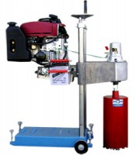 | Portable Core Drill, 17 hp, gasoline engine  Code: 47-5182  Product Group: Core Drill

Further Information
Shown with drill bit; drill bits not included, order separately.

Specification
Engine | Gasoline, 17 hp, with electric starter
Speed | Variable, 300 to 1,500 bit rpm
Drilling Position | Vertical drilling only
Bit Capacity | Up to 16" (406 mm) diameter
Column Travel | 24" (610 mm)
Weight | Net 315 lbs. (143 kg).

