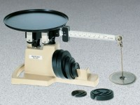 | Multi-Purpose Field Scale - 16 kg Capacity  Code: 88-1610  Product Group: Multi-Purpose Field Scales

Specification
Capacity | 16 kg.
Readability | 5 g.
Poise | Sliding.
Beam | 2 x 0.01 lb. and 500 g and 5 g; metric 500 x 5 g.
Platform | 10â (254 mm) diam.
Handle | Cast-in base.
Attchment Weights | Slotted ratio type; for full capacity.
Overall Dimensions | 23 -1/4â w. x 9-3/4â d. x 10-1/8â h. (565 x 24 8 x 25 7 mm).
Weight | Net 23 lbs. (10.4 kg).

