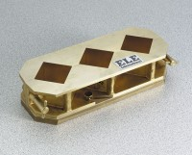 | Cement Cube Mould - ASTM  Code: 39-0412  Product Group: Cement Cube Mould (ASTM)  Three-gang mould, bronze.

Standards
ASTM C87, ASTM C109, ASTM C141, ASTM C579, ASTM C593, AASHTO T106

Specification
Sample Size | Up to three 2â (50.8 mm) cubes.
Construction | Forged bronze; three-gang with wideflanged  top and base; machined and ground finish.
Mold Closure | Mechanical; âTâ bolt screw clamps held in place by snap rings.
Base Plate | Machined forged bronze with knurled holddown  screws.
Weight | Net 12 lbs. (5.4 kg).

