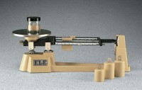 | Triple Beam Scale - 2,610 g Capacity; with Undivided Tare Beam, Tares up to 225 g  Code: 78-7142  Product Group: Triple Beam Scales

Specification
Capacity | 2,610 g.
Readability | 0.1 g.
Platform | Stainless steel plate; 6â (152 mm) diam.  except for scale with scoop models.
Damping | Magnetic.
Attchment Weights | One 500 g; two 1,000 g (included).
Dimensions | 18â w. x 6â d. x 7â h. (45 7 x 152 x 178 mm).
Weights | Net 8 to 10 lbs. (3.6 to 4.5 kg).

