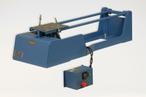 | Jolting Table 220 - 240 V 50 Hz  Code: 39-1150/01  Product Group: Jolting Table  Supplied without moulds.

Standards
EN 196-1, EN 413-2, EN 459-2, EN 1744-1, EN 1015-10, EN 1015-11, EN 13454-2, ISO 679, BS 3892-1, BS 4551-1

Further Information
**NOT AVAILABLE FOR SALE IN THE USA**

Spares/Consumables
 | Mortar Sand  Code: 39-1170
Scraper
Code: 39-1130

