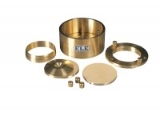 | 75mm Dia Upper and Lower Porous Stones for Use on EL25-0503 Series Cell.  Code: 25-0503/13  Product Group: BS EN consolidation cells and accessories, Fixed Ring Consolidation

Standards
BS 1377, EN 1997-2

