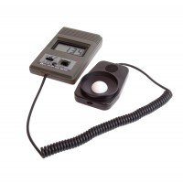 | Digital Lux Meter  Code: 505-092  Product Group: Light measurement  • High accuracy and wide range.  • Remote sensor head.  • Ideal for field work.  This portable lightmeter is for monitoring illuminance and gives a digital display in Lux. This simple to use instruments has only two controls; a power button and a range switch. It is ideal for field survey work and initial investigations.

Further Information
Supplied complete with sensor head.

