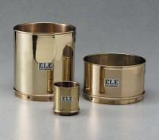 | Wet Washing Sieve - 3” diam. x 3-1/2” h. x 3” depth to mesh (76 x 89 x 76 mm).  Code: 79-7010  Product Group: Wet Washing Sieves

Standards
ASTM E11

Specification
Frame | Brass
Mesh | Brass
Weight | Net 2 lbs. (0.9 kg)

