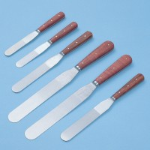 | Spatula 150 mm  Code: 81-0120  Product Group: Spatulas

Further Information
**NOT AVAILABLE FOR SALE IN THE USA**

