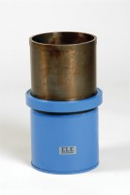 | 100mm Dia Cylinder Mould 200mm Long.  Code: 34-5210  Product Group: Cylinder Moulds  100 mm diameter x 200 mm long, complete with base plate.

Further Information
**NOT AVAILABLE FOR SALE IN THE USA**

