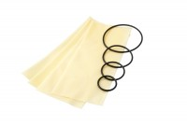 | Membrane Sealing Ring 38mm/1.5 Inch Diameter. Pack of 10.  Code: 25-5081  Product Group: Membrane Sealing Rings  Membrane Sealing Ring 38Mm Diameter (Pack Of 10).

