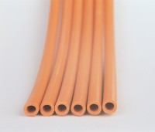 | Rubber Tubing  Code: 81-0375  Product Group: Vacuum Pumps, Rubber Tubing

Further Information
**NOT AVAILABLE FOR SALE IN THE USA**

