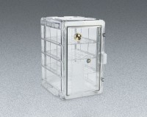 | Desiccator Cabinet  Code: 88-6700  Product Group: Tall Non-Vacuum, Dessicator Cabinet, Bitumen Extraction Test

Specification
Construction | Molded co-polyester plastic with dual hinged gasketed door and two locking latches.
Shelves | Clear with small vent holes; three included.
Door Opening | 8.9â x 16.4â h (41 .7 x 22 .5 cm).
Overall Dimensions | 13 .4â x 16.3â x 20.4â h. (34 .1 x 41 .4 x 51 .8 cm).

