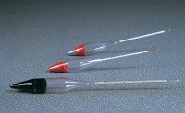 | Soil Hydrometer Type 152H ASTM/Aashto Graduated -5 to + 60G/Litre.  Code: 24-4640  Product Group: ASTM Soil Hydrometers, Soil Hydrometers  Graduated –5 to +60 g/litre.

Standards
BS 1377, EN 1997-2, ASTM D422, ASTM E100, AASHTO T88

Specification
Construction | Molded, seamless.
Scale | Bouyoucos; double scale.
Calibration | At 68Â°F.
Weight | Net 4 oz. (113 g).

