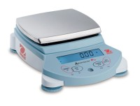 | Ohaus Electronic Balance - 3,100 g Capacity  Code: 88-1054/02  Product Group: Ohaus Series Electronic Balances

Further Information
100-240V, 50/60 Hz.

Specification
Maximum Capacity | 3100 g
Readability | 0.01 g
Repeatability (Std. Dev.) | 0.01 g
Linearity | +/-0.02g
Internal Calibration | NO
Pan Size (in/cm) | 7.9 / 18
Dimensions w x h x d (in/cm) | 7.7 x 3.6 x 12 .6  in / 19.6 x 9.2 x  32 cm
Shipping Wt. (lb/kg) | 11 .8 lb /  5.4 kg

