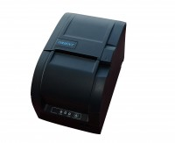 | Impact Printer Rs232 Serial Connection. Supplied Complete with 1 Paper Roll.  Code: 37-4859/01  Product Group: Printing of results  Supplied complete with serial RS232 communications cable and one paper roll.

Further Information
**Not available for sale in the USA**
220 - 240 V AC, 50 - 60 Hz, 1 ph.

Spares/Consumables
 | Paper Roll 76mm Wide (Box of 20)  Code: 37-4859/12
Printer Ribbon(Black/Red) for Use with Impact Printer.
Code: 37-4859/10

