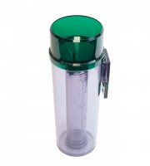 | De-Luxe Plastic Rain Gauge  Code: 460-010  Product Group: Daily Raingauges  Made from strong UV stabilised plastic. The detachable internal collecting jar is calibrated in mm and inches of rain.

Further Information
Supplied with fixing bracket.

