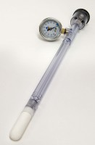 | Jet Fill Tensiometer 900 mm  Code: 514-040  Product Group: Tensiometers  900mm Long

Further Information
Requires Part No 514-034

