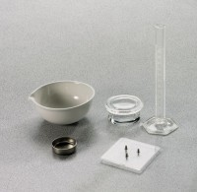 | Shrinkage Limit Set  Code: 2820E  Product Group: Shrinkage Limit Set  Set includes:  1 Monel Shrinkage Dish (24-1550).  1 Crystallizing Dish (24-1600).  1 Shrinkage Prong Plate (24-1500).  1 25 ml Graduated Cylinder (88-6002A).  1 Evaporating Dish (88-6714).

Standards
ASTM D427, AASHTO T92

Further Information
Three pounds of mercury and other accessories required for shrinkage limit test; not included

