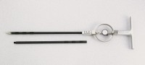 | Proving Ring Penetrometer  Code: 29-3739  Product Group: Proving Ring Penetrometer

Further Information
250 psi capacity

Specification
Proving Ring | 250 lb. (1.1 kN) capacity.
Dial Indicator | Brake type.
Shaft | 3/4â (19 mm) diam. x 18â l. (45 7 mm); graduated at 6â (152 mm) intervals.
Extension Rod | 3/4â (19 mm) diam. x 36â l. (914 mm); graduated at 6â (152 mm) intervals.
Cone | 30 degree; 1 sq. in.; replaceable.
Handle | Cast aluminum.
Weight | Net 12 lbs. (5.4 kg).

