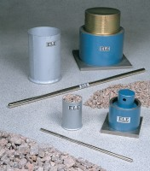 | 75mm Aggregate Crushing Value Apparatus. Supplied Complete with Metal Measure and Tamping Rod.  Code: 42-4500  Product Group: Aggregate Crushing Value (ACV) and Ten Percent Fines Value (TFV)  Comprising of 75 mm nominal diameter steel cylinder, plunger and base plate supplied complete with metal measure and tamping rod.

Further Information
**NOT AVAILABLE FOR SALE IN THE USA**

