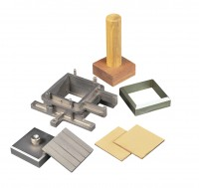 | Shear Box Assembly 100mm Sq.  Code: 26-2197  Product Group: Shear Box Assemblies, Shear Box Assemblies  •Manufactured from corrosion resistant materials  •Sample size 100 x 100mm x 25mm high meeting BS 1377  •Incorporates PTFE faced box separation screws to reduce friction  •Supplied complete with upper and lower porous plates and loading pad  •Suitable for quick undrained or drained/residual tests.

Standards
ASTM D3080, AASHTO T236

Further Information
All shearbox assemblies are designed to fit the carriage of 26-2114 series Digital Direct/Residual Shear Apparatus. They are supplied complete with three porous plates, one retaining plate and a loading pad. The three sizes supplied comply with the relevant requirements of BS 1377 and ASTM D3080. All assemblies can be used for quick shear tests or drained/residual shear tests.
Optional accessories are available including specimen cutters and extrusion tools.

Specification
Specimen area | 100 x 100 mm
Specimen thickness | 25 mm
Weight kg | 5.2
Relevant standard | BS 1377

Spares/Consumables
Specimen Cutter 100mmsq.
Code: 26-2201

