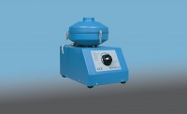 | Rotatest 3000  Code: 45-3815/01  Product Group: Asphalt Centrifuge Extractors  Centrifuge extractor used to determine the quantitative amount of bitumen in bituminous paving mixtures. Variable speed control from 0 to 3600 rpm through the front panel mounted control knob and brake control included for rapid deceleration.  Precision machined aluminium removable cover with integral cup for adding solvent, with sealed cast aluminium housing.  For 220 V AC, 50 - 60 Hz, 1ph.

Standards
EN 12697-1, ASTM D2172, AASHTO T164

Further Information
**NOT AVAILABLE FOR SALE IN THE USA**
3000 g capacity. Supplied with 100 Filter Discs. For 220 V AC, 50 - 60 Hz, 1ph.

