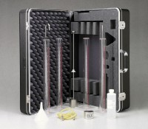 | Sand Equivalent Test Set  Code: 24-4917  Product Group: Sand Equivalent Test Set  Set Includes:  1 Solid Rubber Stopper.  1 2-Hole Rubber Stopper.  1 Pinch Clamp.  1 Carrying Case.  1 Weighted Foot Assembly.  1 Funnel.  1 Irrigation Tube.  1 Siphon Tube.  1 Blow Hose.  1 Measuring Can 85ml +/- 5ml.  1 Bottle Stock Solution.  4 Sand Equivalent Cylinders.

Standards
ASTM D2419, AASHTO T176

Specification
Stock Solution | Mixture of calcium chloride and glycerin.
Carrying Case | Plastic; holds all components.
Weight | Net 22 lbs. (10 kg).

Spares/Consumables
 | Sand Equivalent Cylinder  Code: 24-4917/10
Stock Solution 1 gallon
Code: 24-4938
Stock Solution 8 oz.
Code: 24-4936

