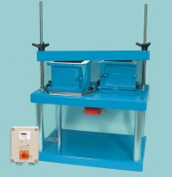 | Vibrating Table 600 X 400mm Table Top. 220-240V 50Hz 1Ph.. Supplied with clamping assm.  Code: 34-6250/01  Product Group: Vibrating Table  Vibrating table mounted on a steel stand, supplied with clamp assembly.

Further Information
**NOT AVAILABLE FOR SALE IN THE USA**
3000 cycles per minute. For 220 - 240 V AC, 50 Hz, 1 ph.

Specification
Dimensions (table top) | 600 x 400 mm
Maximum no. Cube moulds | 2 x 150 mm²
Clamp Assembly | Single
Weight | 60 kg

