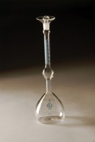 | Le Chatelier Flask  Code: 38-1200  Product Group: Specific Gravity (relative density) of Hydration Cement, Le Chatelier Flask  For determining the density of hydraulic cement and lime, supplied complete with calibration certificate. Capacity 250ml. Graduated from 0 to 1ml and from 18 to 24ml graduations. Accurate to 0.05ml.

Standards
EN 196-6, ASTM C128, ASTM C188, E 694, AASHTO T133

Specification
Graduations | Zero mark represents 250 ml, the capacity of the large bulb; neck graduations from 0-1 ml in 0.1 ml divisions with two extra 0.1 ml graduations above the 1.0 and below the 0 marks; bulb portion of neck holds 17 ml; top portion of neck graduated from 18-24 ml in 0.1 ml divisions; 24 ml capacity.
Stopper | Ground glass.
Weight | Net 8 oz. (227 g).

