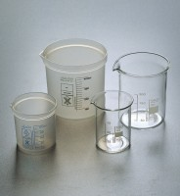 | Beaker Cover  Code: 82-0260  Product Group: Beakers and Covers  Watch glass. Borosilicate glass, 100 mm dia.

Further Information
**NOT AVAILABLE FOR SALE IN THE USA**

