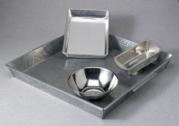 | Mixing Pan - Square Tin  Code: 88-7140  Product Group: Mixing Pans and Bowls  Tin; 7-3/4” x 7-3/4” x 2” (197 x 197 x 51 mm).

