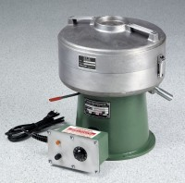 | Centrifuge Extractor 1,500 g  Code: 45-3820/02  Product Group: Asphalt Centrifuge Extractors, Bitumen Extraction Test

Standards
ASTM D2172, AASHTO T164

Further Information
120vAC, 60 Hz, 1ø.

Specification
Control | Variable speed, 0-3,600 rpm; brake for fast  stopping.
Motor | 1/6 h.p.
Cover | Aluminum; removable, with integral cup for  adding solvent.
Housing | Aluminum; removable, sealed.
Bowl | Aluminum; removable.
Filter Discs | 10 included.
Dimensions | 17” w. x 17” d. x 18” h.  (432 x 432 x 45 7 mm).
Weight | Net 85 lbs. (38.6 kg).

